SUBASHREE.N-192521377
LAB EXPERIMENTS
EXP 11: DATABASE WITH AUTO_INCREMENT SEQUENCES
OUTPUT:
1:
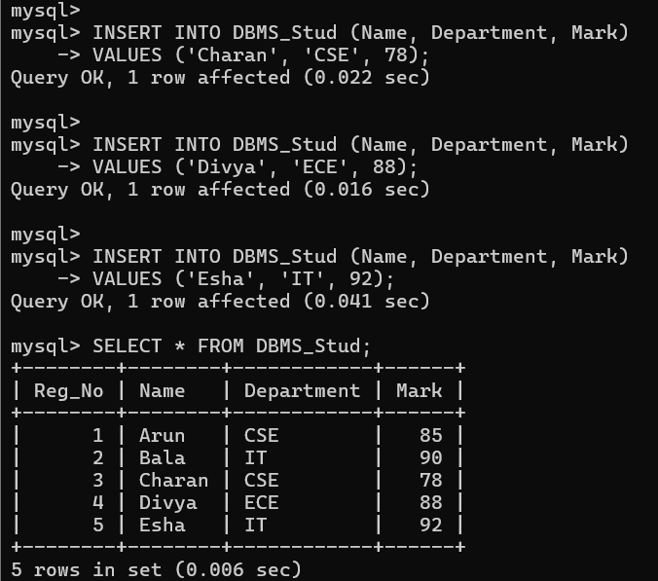
2:
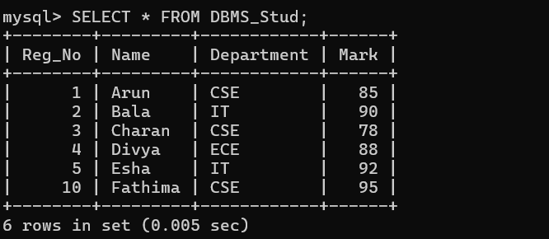
3:
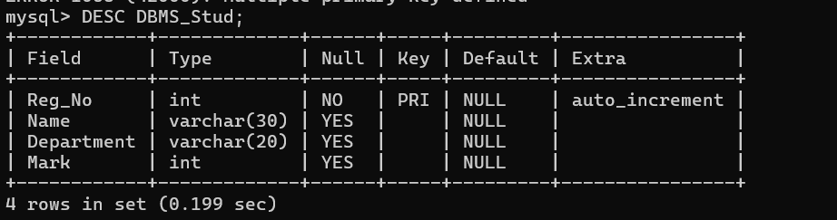
4:
